**Code Analysis**

1. Draw an approximation of the output for the following code:

for (int line = 1; line <= 10; line++)

{

g2.drawLine (1,1,10,line);

}

This program will draw 10 lines and its y value will change while x will remain constant.

The process below will run 10 times

1. Draw an approximation of the output for the following code:

for (int line = 1; line <= 10; line++)

{

g2.drawLine (1,line,10,line);

}

1. Draw an approximation of the output for the following code:

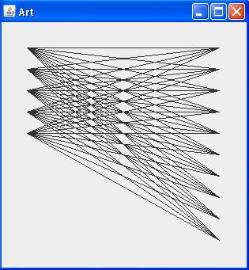

Five iterations

for (int left = 1; left <= 5; left++)

{

for (int right = 1; right <=10; right ++)

{

g2.drawLine (1,left,10,right);

}

}

1. Draw an approximation of the output for the following code:

for (int left = 1; left <= 10; left++)

{

for (int right = 1; right <=left; right ++)

{

g2.drawLine (1,left,10,right);

}

}

1. Draw an approximation of the output for the following code:

for (int left = 1; left <= 10; left++)

{

for (int right = 1; right <=10; right ++)

{

if (left + right >10)

{

g2.setColor(Color.RED);

}

else

{

g2.setColor(Color.BLACK);

}

g2.drawLine (1,left,10,right);

}

}

1. Write the code that would create the following pattern:

